Project LunarX Status Report

Date: May 20, 2016

To: Tejasvi Kothapalli

From: Andrew Kou

Subject: Status Report 5/20

**Accomplishments**: During this week we accomplished various things related to the code of the game. Tejasvi perfected the zoom and the viewing screen shifts based on the rocket position. Additionally, he made the method that drew the landscape a lot cleaner by using various java classes the could be imported. Finally, Tejasvi got the collision of the rocket with the landscape to work. Andrew on the other hand worked and perfected the explode method of the rocket when it collides with the landscape. Additionally, Andrew tweaked various parts of the game such as the rocket shape and font style in order to make the game more appealing.

**Problems/Risks:** One of the bugs that was previously mentioned has now taken a different form due to the changing of the landscape method. Most of the time the landscape generates fine but every now and then flat blue lines appear at the middle of the screen. The bug case is show below: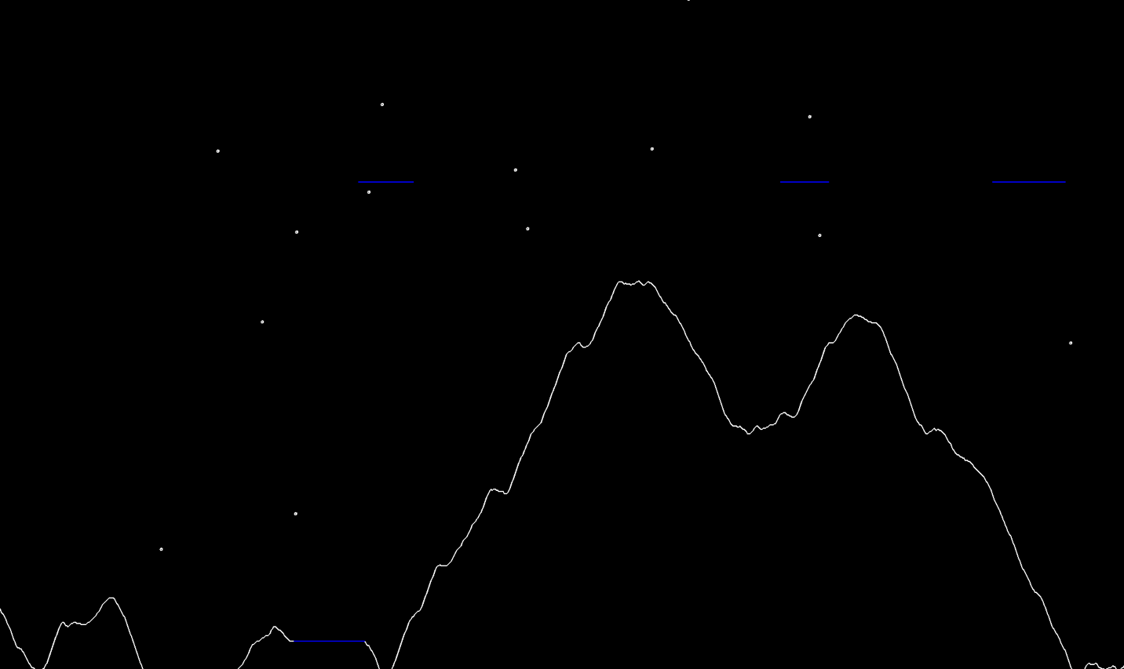

In addition to this bug, there are bound to be more bugs that we will discover as we continue to run the program more and more. We need to identify any possible bugs and find out how to eliminate them. Another problem is time. We need to finish the complete functionality of the code and begin testing as soon as possible, because the deadline is coming up very soon.

**Next Steps:** We will continue to polish up the game, such as by implementing the start menu and the functionality of restarting the game whenever a landing/collision happens. Then, we will work on testing. We will divide the testing evenly based on the classes that each team member wrote. At the same time, we must also write the documentation. Each person on the team will write the respective documentation for the classes that they wrote.